**Anudip Foundation**

A

PROJECT REPORT ON

**“PERSONAL FINANCE TRACKER ”**

SUBMITTED BY

**StudentID:AF04957025**

**Student Name: Jinal Makwana**

UNDER GUIDENCE

**MISS.RAJSHRI C. THETE**

# ACKNOWLEDGMENT

I would like to thank the people who helped me in completion of this project and with deep content and pleasure I express my gratitude toward those people who have given me their precious time and guidance in developing project. It’s my privilege to express my sincere thanks and demo sense of gratitude to my guide Miss. Rajshri Thete for imparting me valuable guidance during the preparation of these papers. She helped me by suggesting me many references of emerge out with a perfect presentation.

Thanking You.

Sincerely,

Personal Finance Tracker .

# Index

|  |  |  |
| --- | --- | --- |
| **Sr. No** | **Particular** | **Page No.** |
| 1 | Introduction | 4 |
| 2 | Objectives | 5 |
| 3 | Proposed System | 6 |
| 4 | Feasibility study | 7 |
| 5 | Hardware & Software requirements | 8 |
| 6 | System Design | 9 |
|  | 6.1 ER Diagram  6.2 System Architecture | 9  10 |
| 7 | Database | 11-13 |
| 8 | I/O screen | 14-27 |
| 9 | Benefits | 28 |
| 10 | Future enhancement | 29 |
| 11 | Conclusion | 30 |
| 12 | Bibliography | 31 |

# INTRODUCTION

Managing personal finances has become an essential skill in today’s fast-paced digital world. With multiple income streams, rising expenses, and the need for structured savings, individuals often face difficulties in keeping track of their money. A **web-based Personal Finance Tracker** provides a practical solution by offering users an organized and accessible way to monitor and manage their finances.

This system is designed as a simple yet effective platform where users can record income, categorize expenses, set budgets, and track savings goals. Unlike scattered spreadsheets or manual logs, the tracker brings all financial information together in one place, ensuring accuracy, convenience, and real-time insights.

The main purpose of this project is to empower users to make informed financial decisions. By highlighting spending patterns, generating reports, and providing visual dashboards, the system helps individuals understand their financial behavior. Whether it is monthly budgeting, bill management, or long-term savings planning, the tracker serves as a reliable personal assistant for money management. Security is a top priority. Sensitive financial data is protected through secure authentication and encrypted storage, ensuring that users can trust the platform with their personal information. Since it is web-based, the tracker ensures accessibility across devices, allowing users to manage finances anytime, anywhere. It features a clean interface, interactive charts, and user-friendly navigation, making it suitable for both beginners and experienced users.

# OBJECTIVES

* To provide a centralized web-based platform for recording and managing income, expenses, and savings.
* Provide an organized way to classify financial transactions and assist in setting up practical budgets.
* To help users create and maintain monthly or yearly budgets, ensuring better financial discipline.
* Maintain high standards of data protection through secure login, encryption, and safe information storage.
* To support informed financial decision-making by offering insights, reminders, and goal tracking.

# PROPOSED SYSTEM

The proposed system is a web-based **Personal Finance Tracker** designed to simplify and automate financial management for individuals. It allows users to record income and expenses, categorize transactions, and monitor savings in a structured manner. Unlike traditional spreadsheets or manual logs, the system provides an interactive dashboard that displays real-time financial insights through charts and reports.

The platform ensures accessibility across devices, offering users the flexibility to manage finances anytime and anywhere. Security is prioritized with features like user authentication and encrypted data storage, protecting sensitive financial details. The system also supports budget creation, reminders for bill payments, and goal-setting features to encourage better financial discipline.

With its modular design, the application can be easily scaled to include advanced functionalities such as investment tracking, tax calculations, and integration with banking APIs. Overall, the proposed system aims to deliver a user-friendly, secure, and insightful solution that empowers individuals to take full control of their financial well-being.

# FEASIBILITY STUDY

Before implementing a system, it is important to check its feasibility from different aspects:

**1. Technical Feasibility**

* The project uses stable and widely supported technologies such as **Java, Hibernate, and MySQL/PostgreSQL**.
* Hardware requirements are minimal, making it suitable for standard PCs or servers.
* The design allows for **future integration with APIs** (e.g., banking APIs, mobile apps).

**2. Economic Feasibility**

* Development cost is low since the system uses **open-source technologies** (Java, MySQL, Hibernate).
* Helps users save money by **tracking expenses, controlling overspending, and managing budgets**.
* Provides high **Return on Investment (ROI)** through improved financial planning and decision-making.

**3. Operational Feasibility**

* The system has a **simple and user-friendly interface**, requiring minimal training.
* Automates manual tasks like expense calculation, budget tracking, and recurring payments.
* Smooth adoption as users can quickly learn to manage accounts, transactions, and goals.

**4. Schedule Feasibility**

* The system is designed in **modular form** (User, Account, Transaction, Budget, Goal, Recurring, Category).
* Development can be done in phases, ensuring faster delivery and testing.
* Estimated development timeline is reasonable, making project completion feasible without major delays.

# HARDWARE AND SOFTWARE REQUIREMENTS

**Hardware Requirements**

* **Minimum:** Pentium IV, 2 GB RAM, 10 GB storage.
* **Recommended:** Intel i3 or AMD RYZEN 7, 8 GB RAM, 50 GB storage, HD display.

**Software Requirements**

* **Operating System:** Windows 7/8/10/11, Linux, or mac OS.
* **Programming Language:** Java JDK 8 or higher.
* **Frameworks/Tools:** Hibernate ORM, Apache Maven.
* **Database:** MySQL / PostgreSQL / Oracle DB.
* **IDE:** Eclipse, IntelliJ IDEA, or NetBeans.
* **Server:** Apache Tomcat.
* **Version Control:** Git / GitHub for source code management.

# SYSTEM DESIGN

**6.1 ENTITY-RELTIONSHIP Diagram**

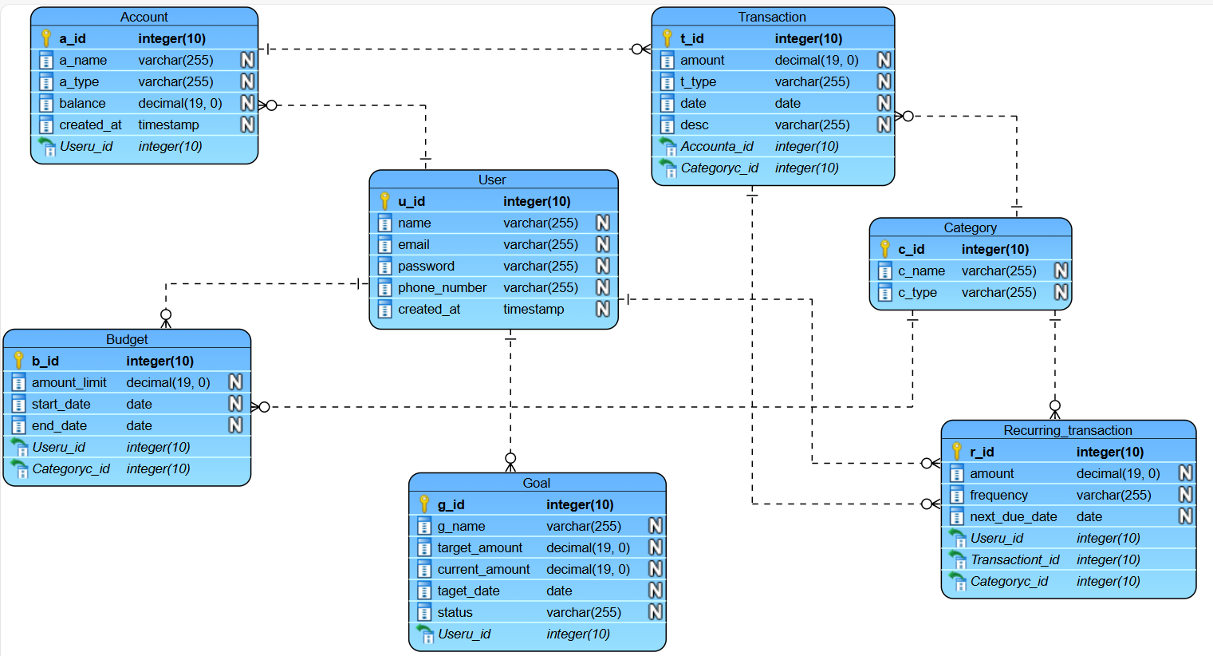

**6.2 System Architecture**

The project follows a **3-tier architecture**:

1. **Entity Layer (Model):**  
   Represents database tables through classes like **User, Account, Transaction, Category, Budget, Goal, Recurring Transaction**. These map directly to data stored in the system.
2. **DAO Layer (Data Access):**  
   Contains interfaces such as UserDAO, AccountDAO, TransactionDAO, etc., with implementations (UserDAOImpl, TransactionDAOImpl) to handle **CRUD operations**. This abstracts database logic from other layers.
3. **Service Layer (Business Logic):**  
   Implements core rules, validations, and calculations. Examples include checking account balances before transactions, monitoring budget limits, updating recurring payments, and tracking goal progress.
4. **Presentation Layer (UI):**  
   Provides interaction for users via **HTML/CSS frontend pages** (for adding/viewing accounts, transactions, budgets, etc.) or through console/REST API. It communicates with the service layer to display results dynamically.

# Data Base Design

**Database Table**

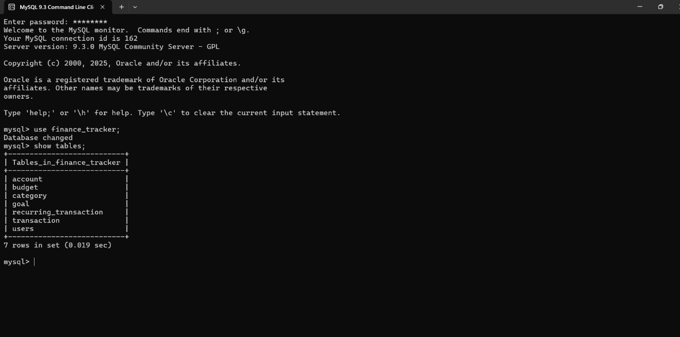

**User**

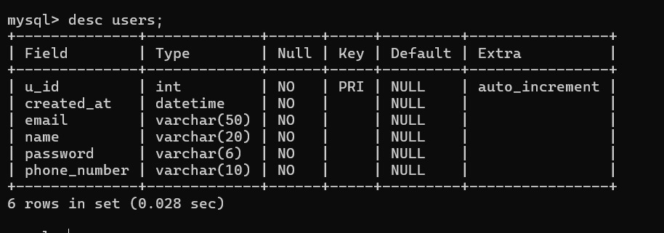

**Account**

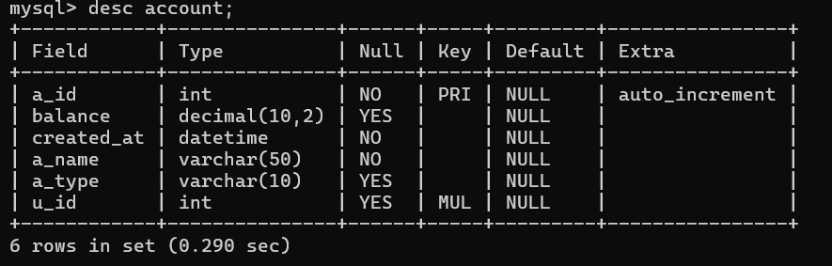

**Category**

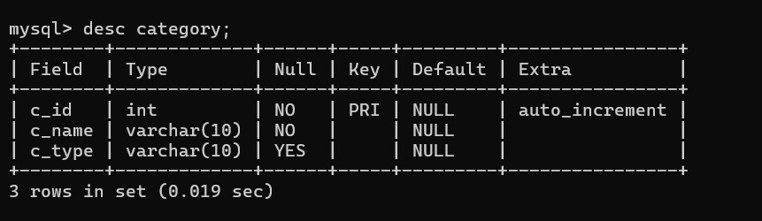

**Budget**

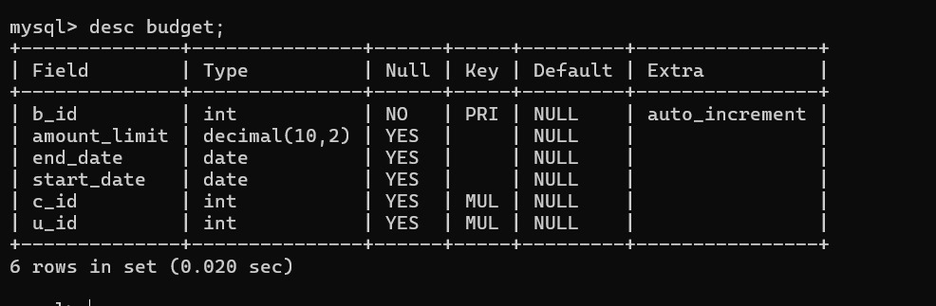

**Transaction**

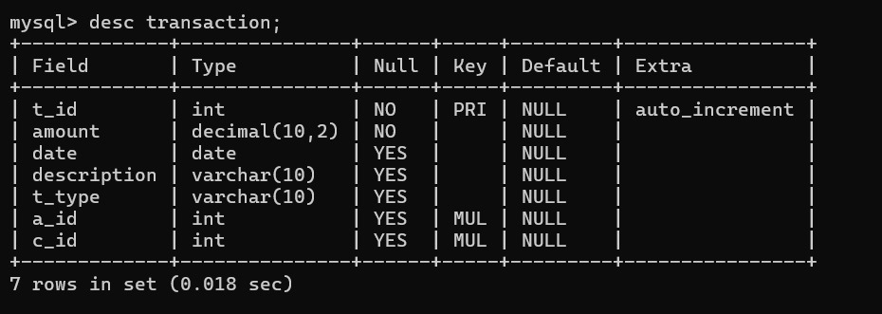

**Goal**

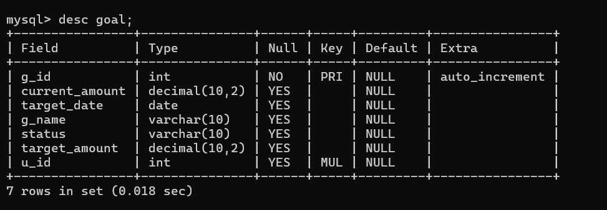

**Recurring_Transaction**

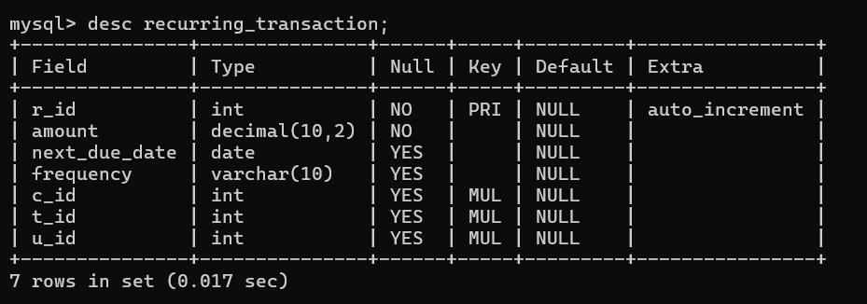

# I/O SCREEN

**User**

**Create User**

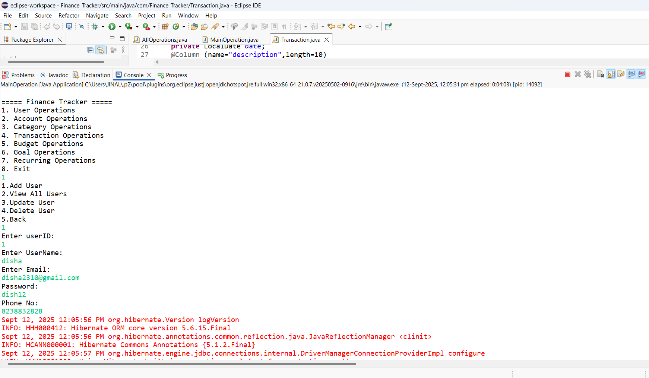

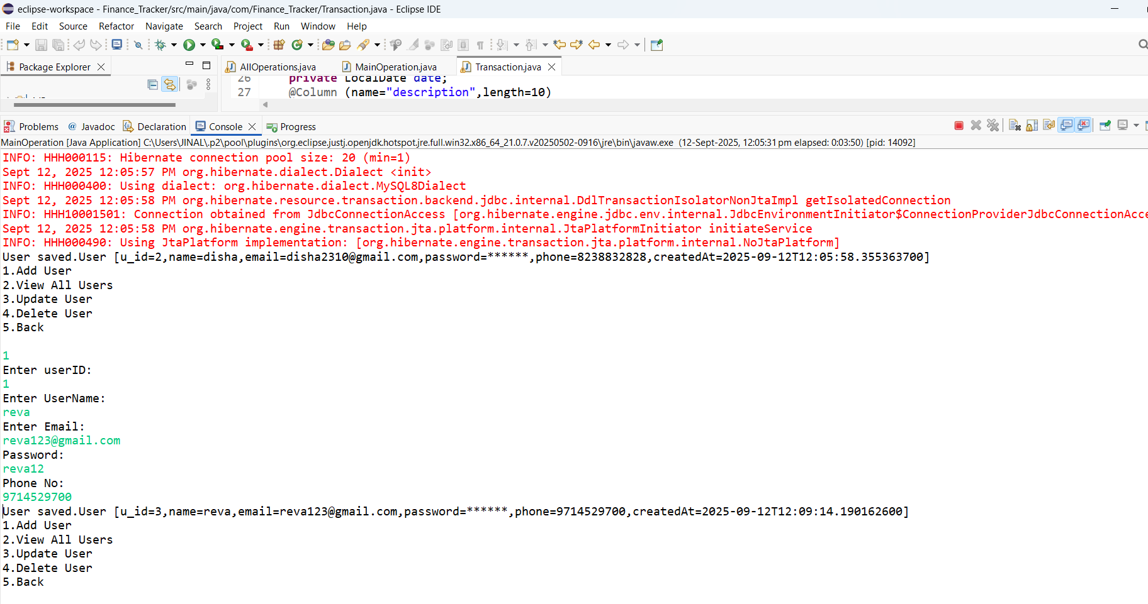

**View All User** 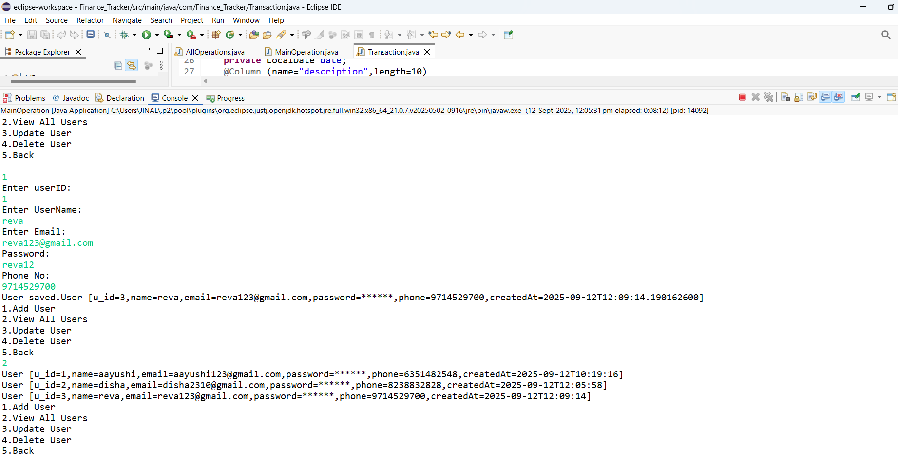

**Update User** 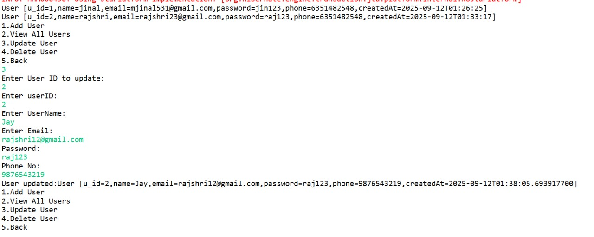

**Delete User** 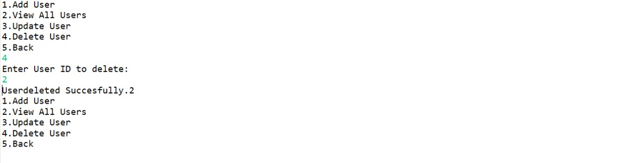

**Account**

**Create Account** 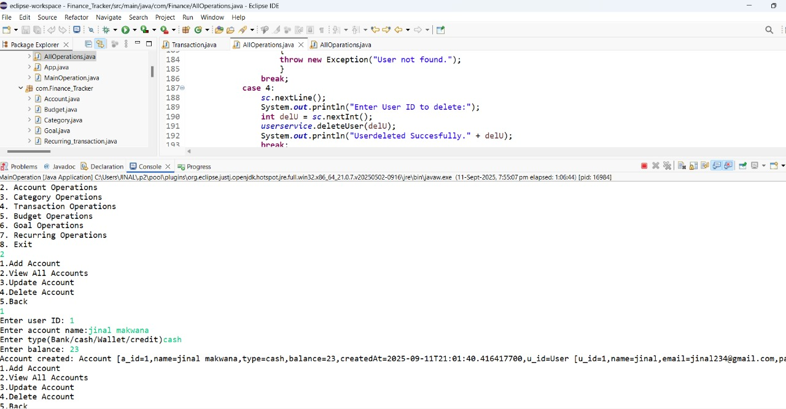

**View All Account** 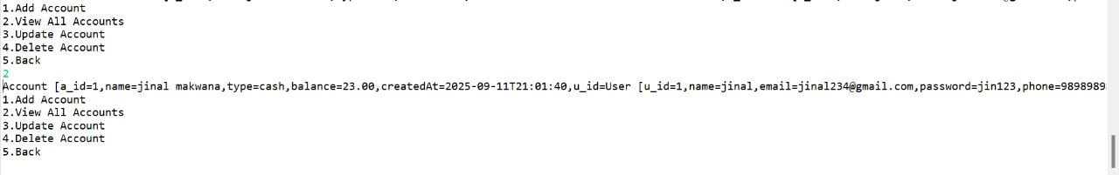

**Update Account** 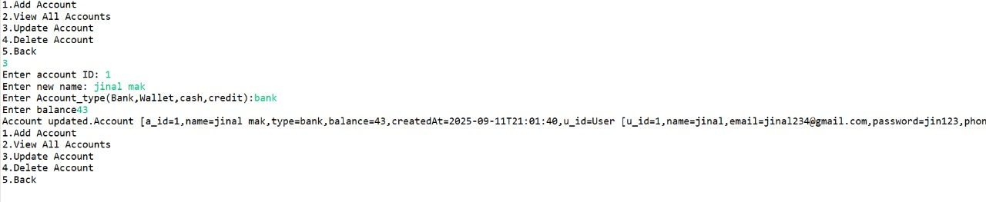

**Delete Account** 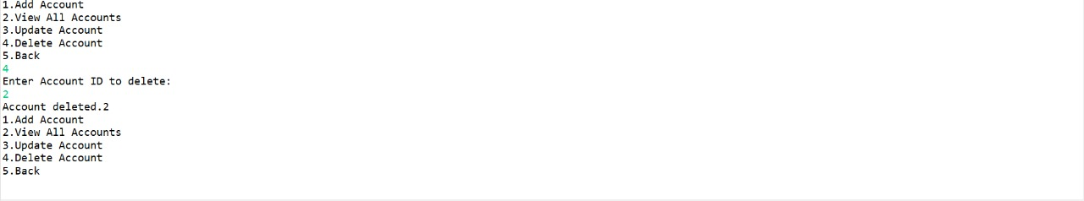

**Category**

**Create Category** 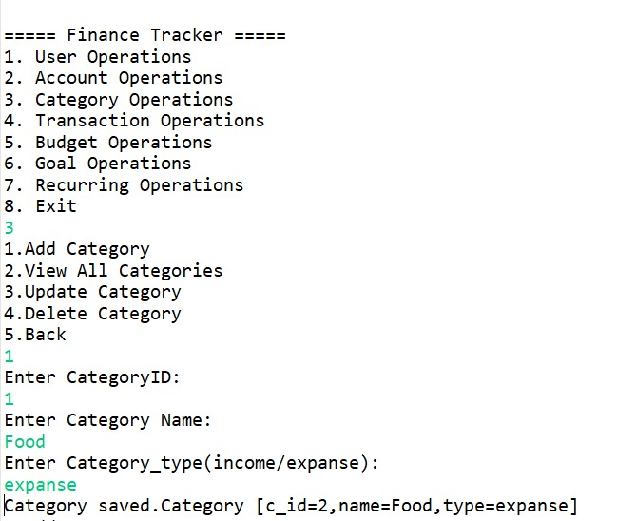

**View All Category** 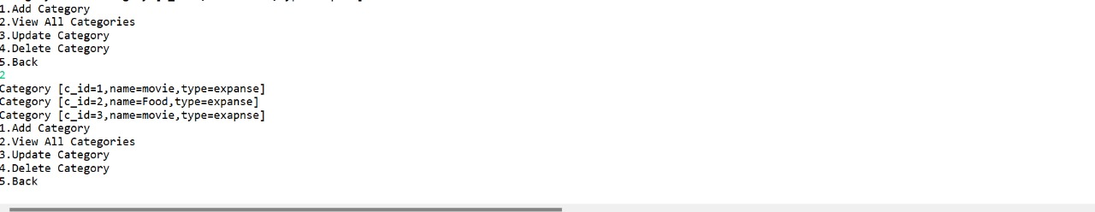

**Update Category** 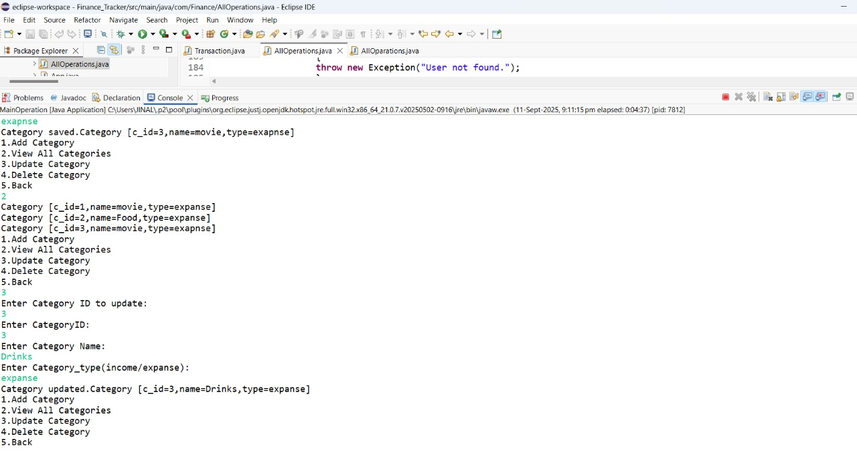

**Delete Category** 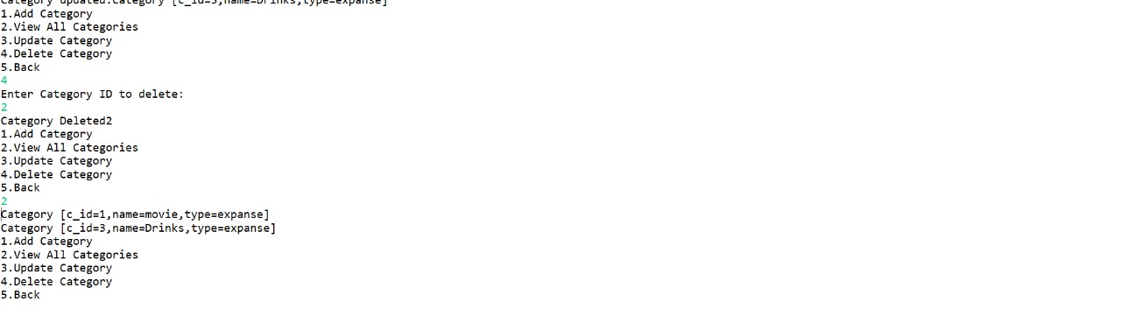

**Transaction**

**Create Transaction** 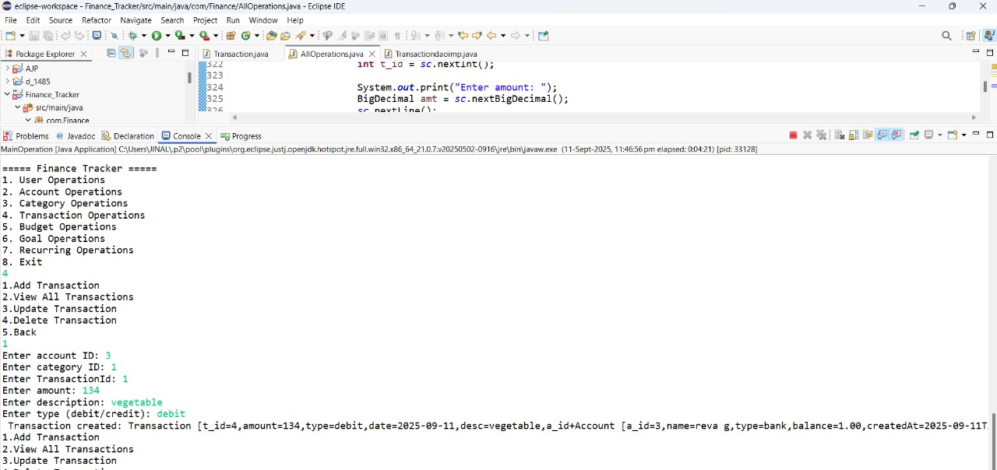

**View All Transaction** 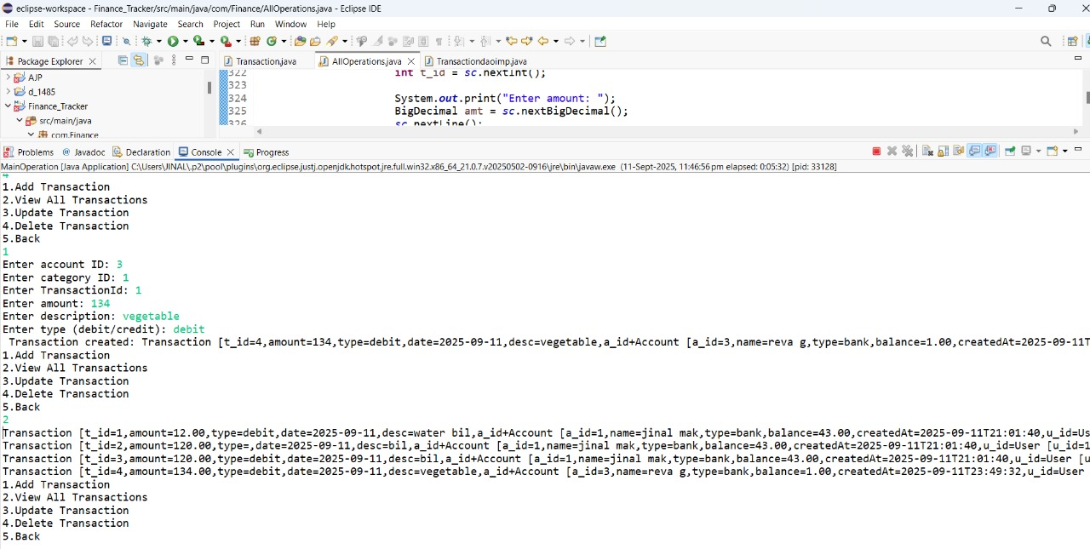

**Update Transaction** 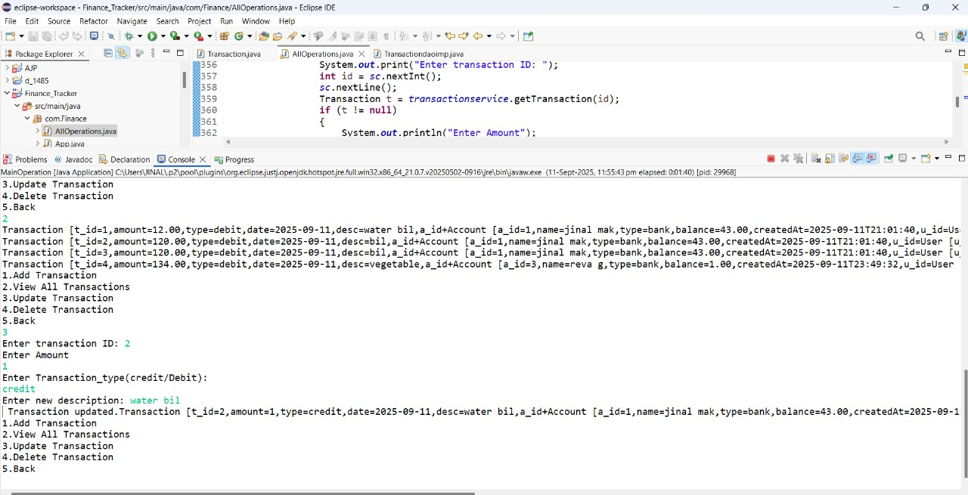

**Delete Transaction** 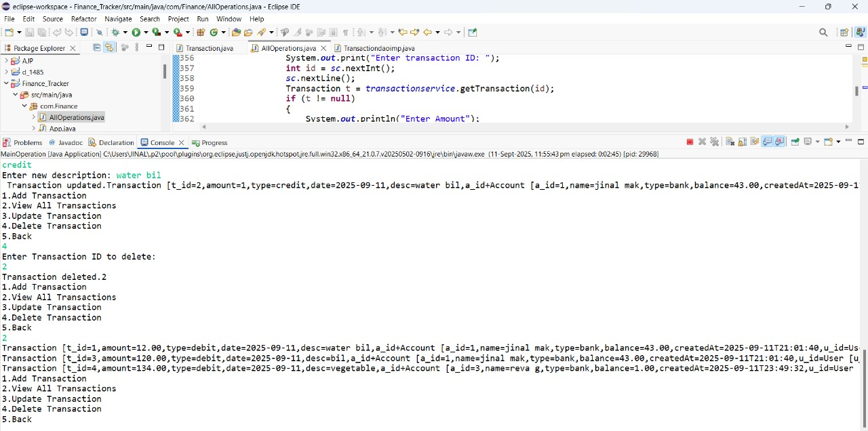

**Budget**

**Create Budget** 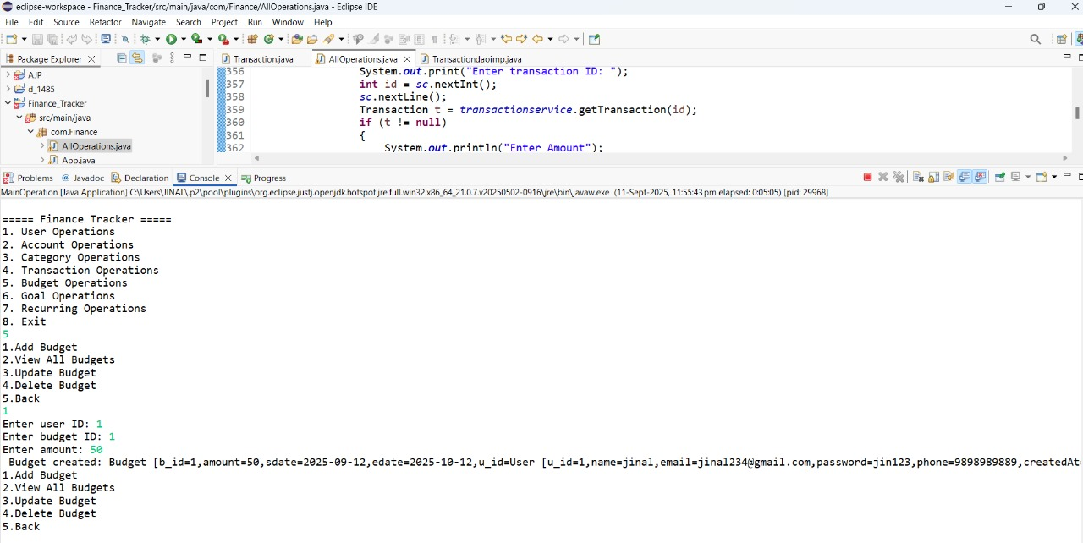

**View All Budget**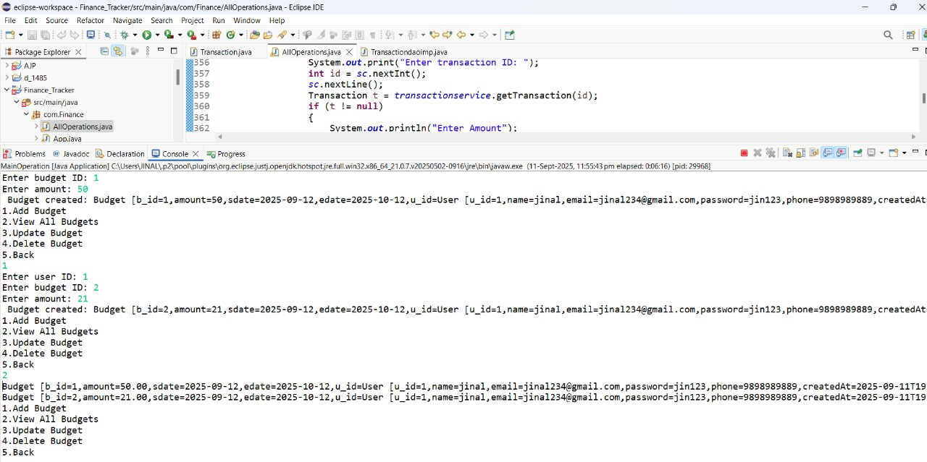

**Update Budget**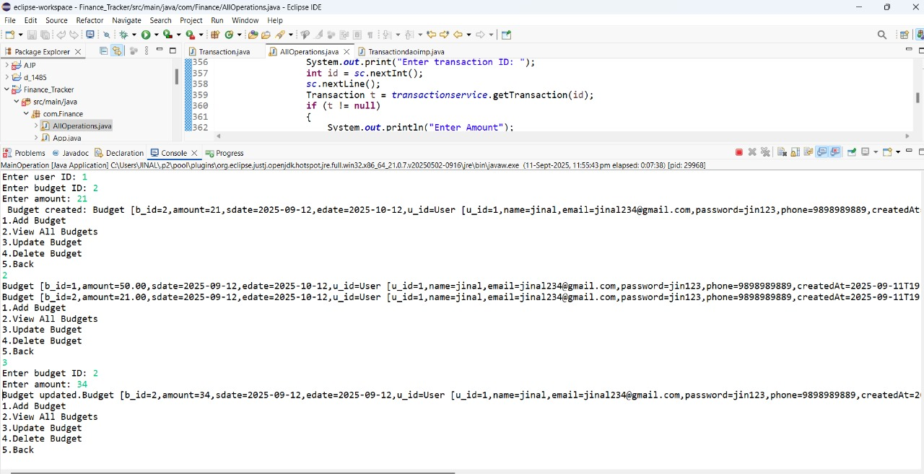

**Delete Budget**

**Goal**

**Create Goal** 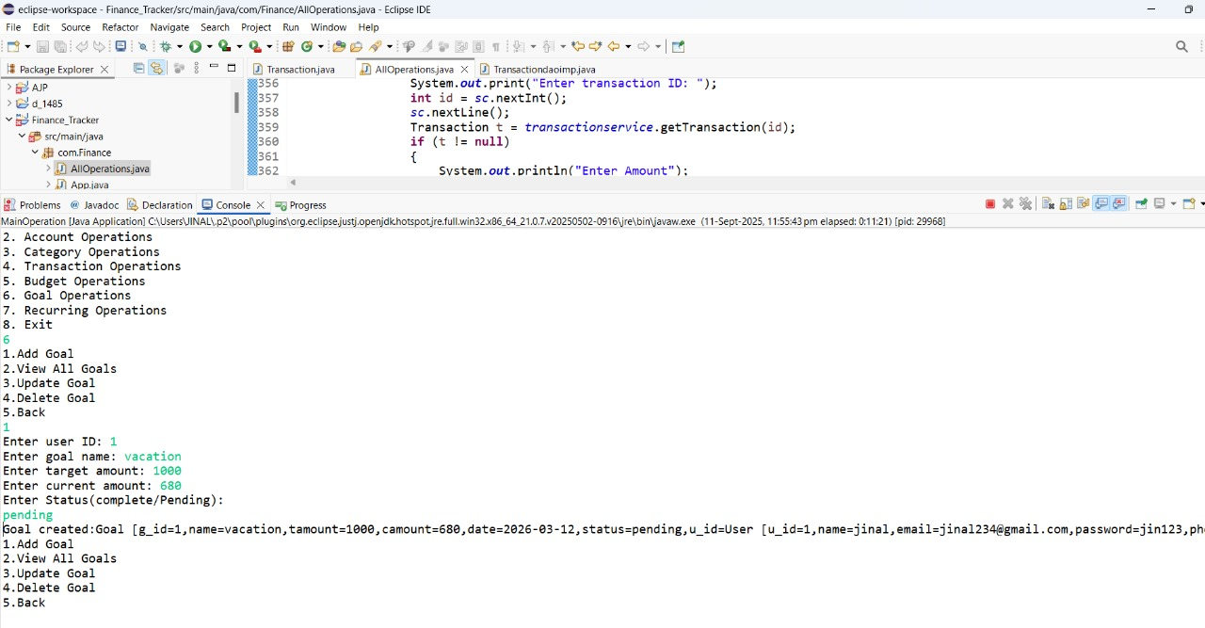

**View All Goal**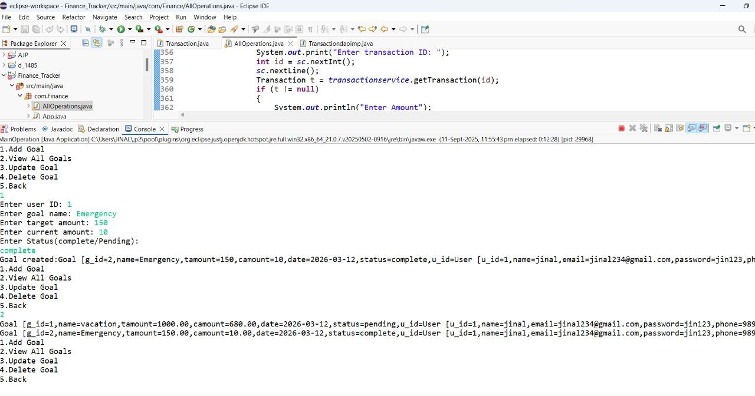

**Update Goal** 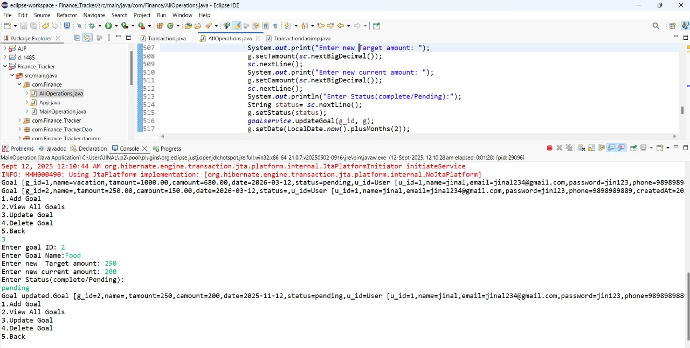

**Delete Goal** 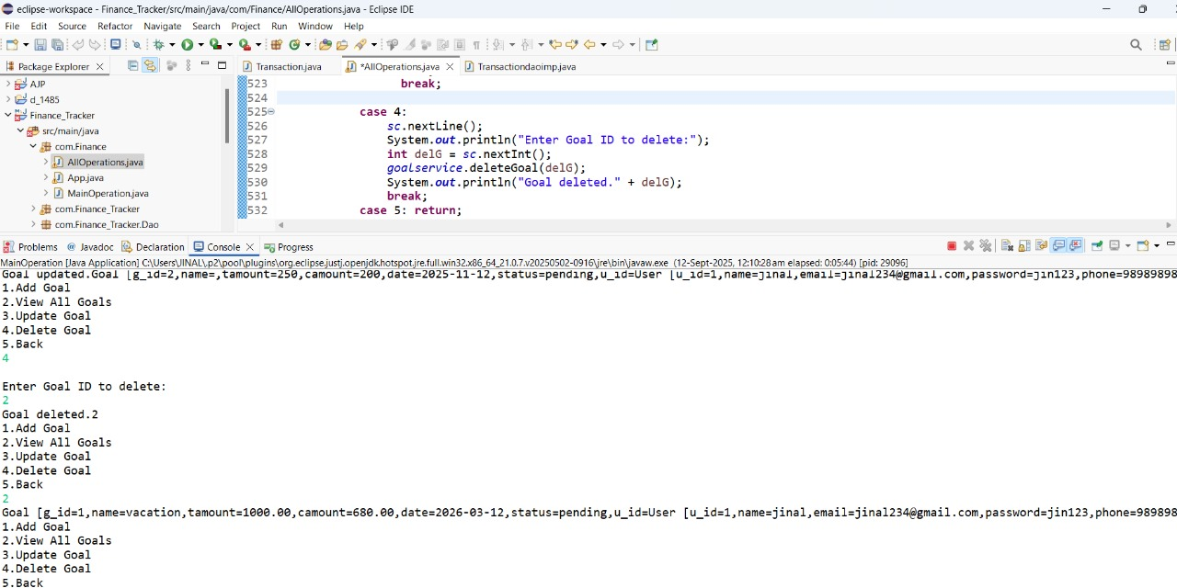

**Recurring_Transaction**

**Create Recurring Transaction**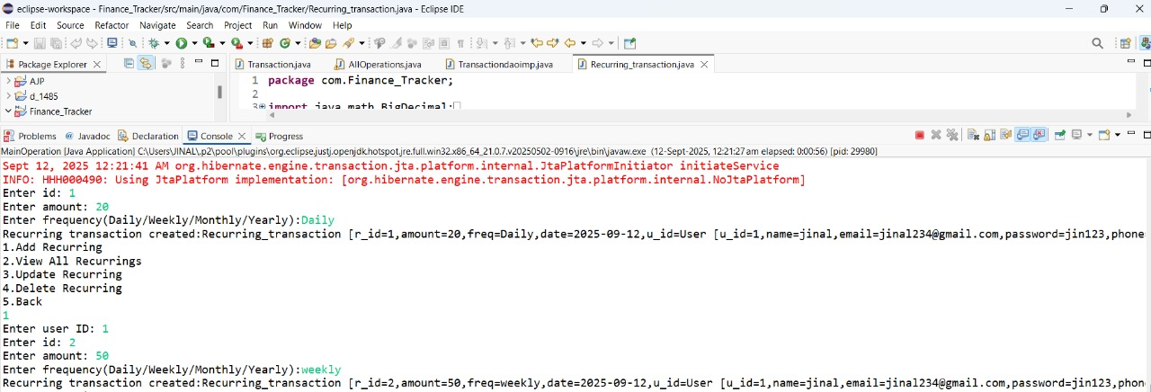

**View All Recurring Transaction**

**Update Recurring Transaction**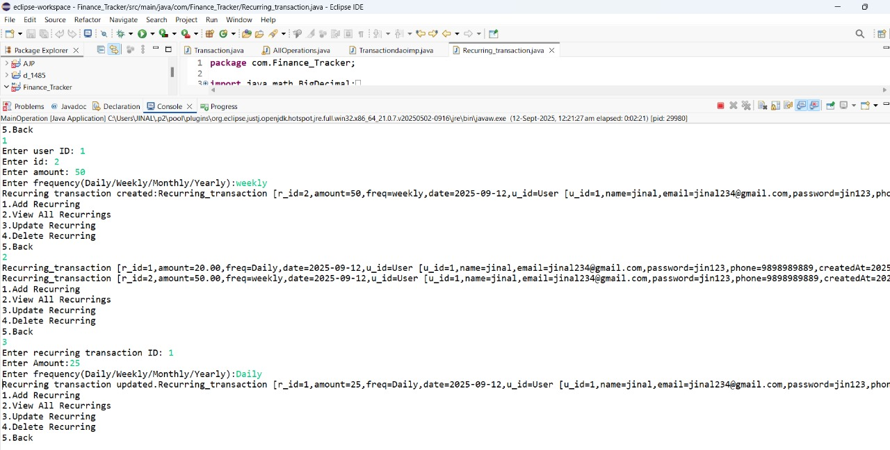

**Delete Recurring Transaction**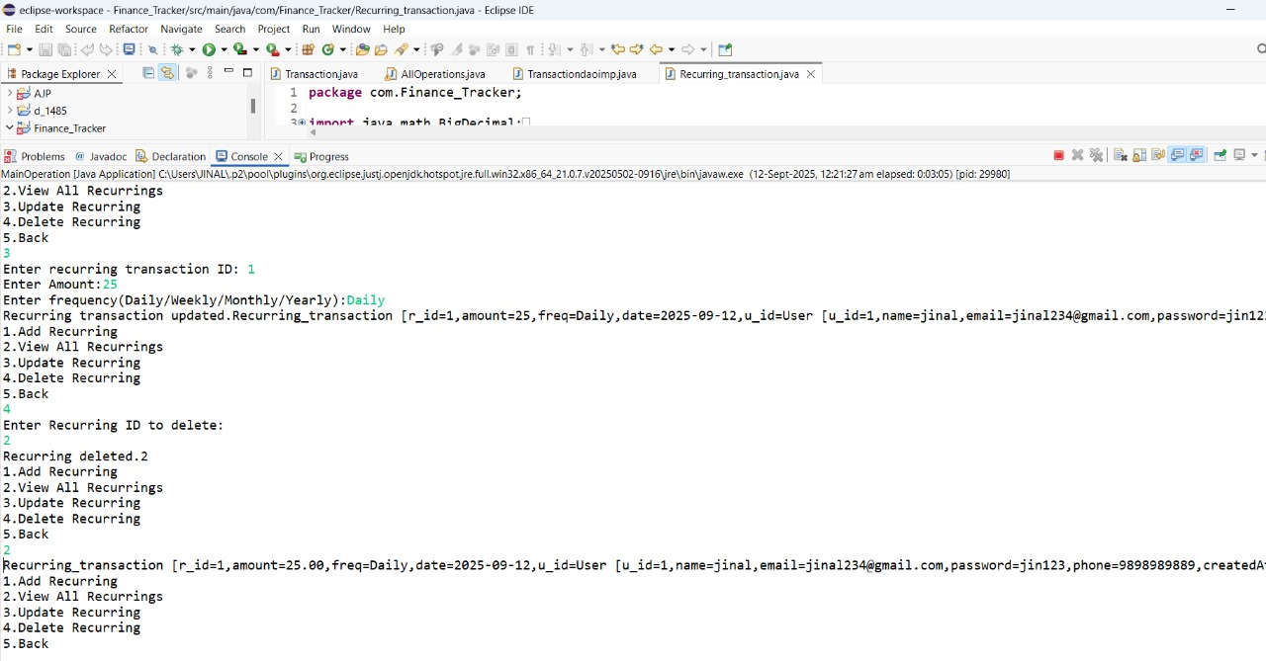

# ****BENEFITS OF SYSTEM****

The **Personal Finance Expense Tracker** provides several advantages:

1. **Efficiency:** Simplifies expense tracking, budgeting, and goal management by reducing manual calculations.
2. **Accuracy:** Minimizes errors in financial records through structured entry of transactions, categories, and budgets.
3. **Transparency:** Users can clearly view income, expenses, balances, and budget usage at any time.
4. **Data Security:** Sensitive financial data is stored securely with proper database constraints and validations.
5. **Accessibility:** Can be easily accessed through a user-friendly interface, with potential future extension to web/mobile apps.
6. **Better Decision-Making:** Provides insights into spending patterns, category-wise expenses, and progress toward savings goals.
7. **User Satisfaction:** Helps users stay financially organized, achieve goals, and build confidence in managing their money.

# ****FUTURE ENHANCEMENT****

The current version of the system provides core functionalities, but it can be enhanced further with:

1. **Bank API Integration:** Connect with real-time banking APIs to automatically fetch transactions and balances.
2. **Mobile App:** Provide Android/iOS applications for anytime, anywhere expense tracking.
3. **Artificial Intelligence:** Suggest smart saving strategies, budget adjustments, and spending alerts based on user behavior.
4. **Chatbot Assistance:** Use AI-powered chatbots for answering user queries and providing financial tips.
5. **Multi-Currency & Multi-Language Support:** Enable global usage by supporting multiple currencies and regional languages.
6. **Cloud Deployment:** Host the system on cloud platforms (AWS, Azure, GCP) for scalability and secure remote access.
7. **Advanced Analytics Dashboard:** Provide visual reports and insights into spending patterns, savings growth, and goal achievement.

# ****CONCLUSION****

The **Personal Finance Expense Tracker** successfully addresses the limitations of traditional manual methods of managing income and expenses by providing a centralized, automated, and user-friendly system. It improves efficiency, accuracy, and transparency while helping users make better financial decisions.

By integrating modern technologies such as AI, mobile applications, and secure cloud deployment, this system has the potential to evolve into a complete digital financial assistant that supports users in achieving financial stability and growth.

In conclusion, the project lays a strong foundation for digital transformation in personal finance management and offers ample scope for continuous innovation and expansion.

### BIBLIOGRAPHY

* Java SE Documentation-Oracle: <https://docs.oracle.com/javase/8/docs/>
* Hibernate ORM Documentation:<https://hibernate.org/orm/documentation/>
* MySQL Reference Manual: <https://dev.mysql.com/doc/>
* Apache Maven Project: <https://maven.apache.org/guides/>
* Eclipse IDE Documentation: <https://help.eclipse.org/>